|  |
| --- |
| Circle Language Spec: Commands |

## Beware of Active Command References in Commands

This is a rule for enforcement of control of a parent command over the execution of its sub-commands. It does not impose any restriction, but just advises you to beware of what you are doing, when you are using an active command reference inside a command.

When you are using an active command reference inside a command, then you are giving up the full control over this sub-command’s execution.

You have to be aware, that when you use an active command reference, the active command reference may already have been executed, or that you may be *waiting* on an external execution to finished. If the external execution won’t finish, then the referring procedure is stuck. If the external command object is an inactive command object, it will never execute, and the command will truly be stuck. A warning should be generated then.

This also has consequences for setting parameters for the active command reference. If it is already executing or has already executed, then you can not overwrite the parameters. This may mean, that it will simply not be allowed to set parameters for an active command reference at all.

It is *not* the rule, to beware of *any* active command reference. It is the rule to just always beware of them in a *parent command*. An *object* can contain an active command reference, in order to for instance allow a user to carry around a reference to an active command, executing on a site somewhere.

### Diagram Notation

You have to be aware, that when you use an active command reference, the active command reference may already have been executed.

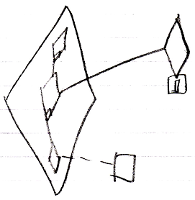

Or that you may be *waiting* on an external execution to finished.

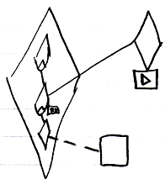

If the external execution won’t finish, then the referring procedure is stuck.

If the external command object is an inactive command object, it will never execute, and the command will truly be stuck. A warning should be generated then.

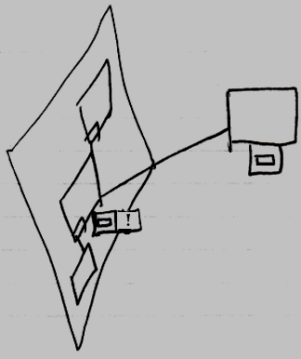

It is *not* the rule, to beware of any active command reference. It is the rule to just always beware of them in a *parent command*. An *object* can contain an active command reference, in order to for instance allow a user to carry around a reference to an active command, executing on a site somewhere.

